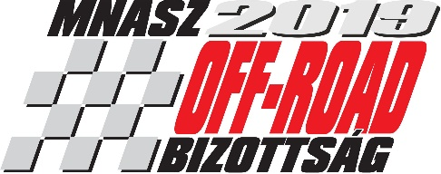

SUPPLEMENTARY REGULATION

International Rallycross Opening Parade

FIA RALLYCROSS CEZ ZONE CHAMPIONSHIP ROUND VIII.

EUROASZFALT HUNGARIAN NATIONAL OPEN RALLYCROSS CHAMPIONSHIP, ROUND VIII.

Venue: Máriapócs RabócsiRing
Date: 27. September – 28. September – 29. September 2019.
(Friday, Saturday, Sunday)

Chapters
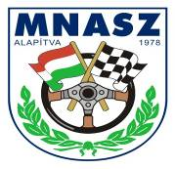
1. Time schedule and venues
2. Organization
3. Organizer
4. The circuit
5. Officials
6. Entry and insurance
7. Prizes
8. Reservation of a right, responsibility of the starters

9. Protection of the environment
10. Safety regulation
11. Checkings
12. Running of the event
13. Parc Fermé - Results – Protests
14. Approval

1. Programme

02. September 2019. Publication of Supplementary Regulation and acceptance of entries
13. September 2019. Closing date for entries at normal fee
From 14. September 2019. Entries at increased fees

Location of the race office: ground floor of the start tower, beside the start grid, left side, opens at 07:00
Location of administrative checking: ground floor of the start tower, beside the start grid
Location of scrutineering and pass registration: ground floor of the start tower, right side, scrutineering area, open at 07:00.
Location of the official notice board: The notice board is located in the paddock, near to the race office.
For sporting checking (administrative checking) you can apply only with valid pass for 2019.
Sporting checking (administrative checking) and technical checking on Sunday only by waiver of the Stewards, and pay penalty.

Timetable
RNOB: Open National Champion; CEZ: Central-Europen Zone Champion

27. September 2019. Friday
13: 00 – 14: 00 Pass registration RNOB+CEZ
(You need send apply to pass registration for the atb@mnasz.hu email address)
14: 00 – 18: 00 Sporting check (Administrative checking) RNOB+CEZ
14: 10 – 18: 55 Technical checking RNOB+CEZ

Sporting checking (Administrative checking) RNOB+CEZ
14: 00 – 14: 20 Sporting check Junior Kupa 20’
14: 20 – 14: 40 Sporting check Suzuki Divízió 20’
14: 40 – 15: 00 Sporting check Astra Divízió 20’
15: 00 – 15: 20 Sporting check Hankook Racer Cup 20’
15: 20 – 15: 40 Sporting check MX5 Kupa 20’
15: 40 – 16: 10 Sporting check Magyar Kupa 25’
16: 10 – 16: 25 Sporting check SuperTouringCars -1600 15’
16: 25 – 16: 45 Sporting check SuperTouringCars -2000 20’
16: 45 – 17: 05 Sporting check SuperTouringCars +2000 20’
17: 05 – 17: 25 Sporting check Super1600 20’
17: 25 – 18: 00 Sporting check SuperCars 35’

Scrutineering - technical checking RNOB + CEZ
14: 10 – 14: 35 Technical checking Junior Kupa 25’
14: 35 – 15: 00 Technical checking Suzuki Divízió 25’
15: 00 – 15: 35 Technical checking Astra Divízió 35’
15: 35 – 16: 00 Technical checking Hankook Racer Cup 25’
16: 00 – 16: 25 Technical checking MX5 Kupa 25’
16: 25 – 17: 00 Technical checking Magyar Kupa 35’
17: 00 – 17: 15 Technical checking SuperTouringCars -1600 15’
17: 15 – 17: 35 Technical checking SuperTouringCars -2000 20’
17: 35 – 17: 55 Technical checking SuperTouringCars +2000 20’
17: 55 – 18: 15 Technical checking Super1600 20’
18: 15 – 18: 55 Technical checking SuperCars 40’
28. September 2019. Saturday

07: 45 Drivers briefing RNOB+CEZ
(in the Education building)
08: 00 1st Steward’s meeting
08: 20 – 09: 40 I. Practice RNOB+CEZ
09: 30 Published 1st Heat Draw
10: 10 – 11: 30 II. Practice RNOB+CEZ
12: 45 – 15: 00 I. Heat RNOB+CEZ
16: 00 – 18: 15 II. Heat RNOB+CEZ

29. September 2019. Sunday

08: 45 – 09: 30 Warm Up RNOB+CEZ
10: 15 – 12: 30 III. Heat RNOB+CEZ
After the III. Heat 2nd Steward’s meeting
13: 00 – 14: 30 Semifinals RNOB+CEZ
15: 00 – 16: 30 Finals RNOB+CEZ

10 minutes after the last final 3rd Steward’s meeting
20 minutes after the last final Prize-giving Ceremony at the start place

2. Organization

The Organizer will organize the VIII. round of the FIA Central Europe Zone Championship, the VIII. round of the EUROASZFALT Hungarian National Open Championship according to the Rallycross regulation valid for 2019.

- Organizer

Organizer of the event RabócsiRing Kft..
Address: 4326 Máriapócs, 094/3 hrsz.
Tel: +36-42-727-272; +36-30-953-2573
Fax: +36-42-727-273
Http: www.rabocsiring.hu
E-mail: ring@rabocsiring.hu
Race office: RabócsiRing office
Address: 4326 Máriapócs, RabócsiRing (periphery)
Phone: +36-30-2740-800

4. General conditions

General
This event will count towards in 2019:
- FIA CEZ Rallycross Championship
- EUROASZFALT Hungarian National Open Rallycross Championship

Description of the circuit
- Location: Máriapócs RabócsiRing
- Phone: +36-30-274-0800
- Joker lap: yes
- Length: 1 320 m
- Length with joker lap: 1 610 m
- Width at the start: 16 m
- Maximum width: 16 m
- Minimum width: 12 m
- Surface: 90% tarmac, 10% loose, gravel

Location:
- From highway M3 towards Nyíregyháza turn off at Nyírbátor, Nagykálló – Kállósemjén – until getting to Máriapócs
- or From highway M3 turn off at Ófehértó, at the 254. No exits, the RabócsiRing is 5 kilometers from the exit. There is a road sign in Máriapócs showing the Circuit RabócsiRing.

5. Officials

Chairman of the Stewards: Vilmos Cselényi
Members of the Steward’s Panel: Attila Mogyorósi
Roman Paskiewicz
Technical Steward: Béla Szilágyi
Clerk of the Course Gergely Éri
Assistant Clerk of the Course Béla Migály
Chief Scrutineer: Tamás Solti
Chief Track Marshal: tba
Secretary of the event: Viktória Szabó
Chief Timekeeper: Attila Boros
Chief Safety Officer: Tibor Kapu
Driver's liaison Officer Katalin Tóth Dr.
Chief Medical Officer tba.

6. Entry and insurance

Anybody wishing to take part in the Event can apply on-line on the www.rabocsiring.hu website or must send the attached entry form duly completed and signed by the competitor and the driver, stamped, to the Organizer. If the drivers’ intention to start is obstacle, he/she must inform the Organizer immediately in written form - e-mail, fax or printed - latest by the beginning of the administrative checking. Otherwise the MNASZ Off-Road Committee will penalize him/her with 10 000 HUF penalty. To the entry form please attach the confirmation paper of the money transfer, without this is the entry not valid. Entries are accepted after the closing date for entries, too, with a reservation according to the regulation.
Entry fee should be paid to the bank account at Erste Bank 11600006-00000000-72809565 or by postal cheque for the next address: RabócsiRing Kft, 4405 Nyíregyháza, Pásztor u. 22. Both of possibility we ask to write the racer’s name in the notification!

Entry fee SuperCars 65 000 HUF
Super1600 60 000 HUF
SuperTouringCars +2000, -2000, -1600 60 000 HUF
Magyar Kupa 45 000 HUF
Swift Kupa 45 000 HUF
Astra Kupa 45 000 HUF
MX5 Kupa 45 000 HUF
Hankook Racer Cup 45 000 HUF
Junior Kupa 30 000 HUF

The entry fee for foreign drivers in CEZ categories 200 €, in national categories 150 €.

This includes the entry fee and the usage fee of the paddock, too. In case of late entry: +100% added to the above mentioned amounts according to the division and cup has to be paid.

Team 30 000 HUF /100 €/

The above mentioned fees are gross prices.

Please mark the requested paddock place on the entry form. The Organizer will accept it according to the priority of the drivers.

Entry pass

The Organizer gives for the Zone and National Championship’s drivers 5 pcs service entry passes (driver+4 pcs service) and 1 pcs paddock entry passes which will be given at the paddock entrance when arriving.
Beyond that are passes for one persons available for both two days of the event, price: 6 000 HUF/pc OR 20 €/pc. Please inform the Organizer about your needs written or by phone.

Insurance

Every driver must have drivers’ insurance. During the entry an insurance premium must be taken out which guarantees the competitors' cover for Civil Responsibility towards third parties. The insurance is valid from start of the event and brakes off at the end of the event or in case of falling out or exclusion

Insurance fee: 4 000 HUF / 15€ / car (no VAT) (the entry fee is including)

The entry fee for the CEZ and National drivers includes the liability insurance fee.

7. Prizes

According to the valid Rallycross regulation.
At the prize-giving ceremony the cups will be held for the winners of the Hungarian Championship and CEZ in front of the tower, next to the start place.

8. Reservation of a right, responsibility of the starters

The Organizer keeps the right for changing this supplementary regulation by the beginning of the event, with the following conditions: in case of any change drivers will be informed by dated and numbered bulletins, which have been approved beforehand by the Committee. After starting the event this right goes to the Stewards' Panel. The participants submit with signing the entry form to the instructions of the supplementary regulation and the bulletins. Participating the event is at participants’ own risk. The drivers declare by signing the entry form that they not raise a claim for right of recovery towards the Organizer, respectively resign of any claim of recovery.
In the depot from 22:30 clocks quiet laws take effect, prohibited the loud music hush, the affray the music player may bring about the confiscation of devices!

9. Protection of the environment

Each driver is requested to ensure that a plastic sheet (minimum dimensions 4 m by 5 m) is spread on the ground in the place reserved for his team where work is to be done on his car, in order to prevent any pollution in case of an accidental leak, etc. and a 150 l trash bag for collecting the rubbish.

10. Safety regulation

Each driver is responsible for ensuring that a min. 5 kg fire extinguisher (able for work properly) is available within his own team area inside the paddock.

11. Checkings

Sporting checking (Administrative checking)

Only drivers must report to administrative checking which will be held at the administrative office (reception building)
15: 00 – 15: 20 Sporting checking Junior Kupa 20’
15: 20 – 15_ 40 Sporting checking Suzuki Divízió 20’
15: 40 – 16: 00 Sporting checking Astra Divízió 20’
16: 00 – 16: 20 Sporting checking Hankook Racer Cup 20’
16: 20 – 16: 40 Sporting checking MX5 Kupa 20’
16: 40 – 17: 10 Sporting checking Magyar Kupa 30’
17: 10 – 17: 25 Sporting checking SuperTouringCars -1600 15’
17: 25 – 17: 45 Sporting checking SuperTouringCars -2000 20’
17: 45 – 18: 05 Sporting checking SuperTouringCars +2000 20’
18: 05 – 18: 25 Sporting checking Super1600 20’
18: 25 – 19: 00 Sporting checking SuperCars 35’

Scrutineering - technical checking
Any car taking part in the Event must be presented to the scrutineering (Scrutineering Checking Place) Any car arriving after the closure of scrutineering may be refused permission to start. Noise: For all cars, a limit of 100 dB is imposed, measured with a noise pressure meter regulated at "A" and "SLOW", placed at an angle of 45° to and a distance of 50 cm from the exhaust outlet. During the checking the car's engine must be turning at 4500 revolutions per minute. (A carpet of 1.50 m x 1.50 m minimum must be placed over the relevant area). The fitting of heat retaining devices or pre-heating is prohibited. This applies both wet-weather and dry-weather tyres.

15: 10 – 15: 35 Technical checking Junior Kupa 25’
15: 35 – 16: 00 Technical checking Suzuki Divízió 25’
16: 00 – 16: 35 Technical checking Astra Divízió 35’
16: 35 – 17: 00 Technical checking Hankook Racer Cup 25’
17: 00 – 17: 25 Technical checking MX5 Kupa 25’
17: 25 – 18: 00 Technical checking Magyar Kupa 35’
18: 00 – 18: 15 Technical checking SuperTouringCars -1600 15’
18: 15 – 18: 35 Technical checking SuperTouringCars -2000 20’
18: 35 – 18: 55 Technical checking SuperTouringCars +2000 20’
18: 55 – 19: 15 Technical checking Super1600 20’
19: 15 – 19: 55 Technical checking SuperCars 40’

12. Running of the event

Practice: There will be not more than 8 cars in each timed practice session. Each driver must complete at least one timed lap during the practice. Should this not be the case, he may be allowed to start at the discretion of the Stewards.

Warm Up duration - NC+CEZ: 2 laps
Free practice duration - NC+CEZ: 4 laps
Number of qualifying - NC+CEZ: 3 heats
Duration - NC+CEZ - qualifying heats: 4 laps
semifinals: 6 laps
finals: 6 laps

At the qualifying heats the number of participant cars is 5, at the semifinals and finals the number of the participant cars is 6.

The qualifying heats can be together, after the qualifying heats will be make a separate heat’s result:
- SuperTouringCars -1600, SuperTouringCars -2000 and SuperTouringCars +2000

The CEZ and NC is running with joker lap.

13. Parc Fermé - Results – Protests

Parc Fermé
Cars having taken part in and having finished (chequered flag) the Finals must be brought by the drivers to the Parc Fermé immediately after the finals, the cars shall remain in the Parc Fermé for at least 30 minutes after the publication of the results. Can be released by decision of the Stewards. In this area, it is forbidden to make any repair to the vehicle or to carry out refueling.

Results
All results will be posted to the Official Notice Board.

Protests – appeals:
All protests will be lodged in accordance with the Code. All protests must be made in writing and handed to the Clerk of the Course or his assistant, or in their absence any of the Stewards of the meeting, together with the sum of 100 000 HUF (general protest), or 100 000 HUF (technical protest).
If the protest requires the dismantling and re-assembly of different parts of a car, the claimant must make a certain deposit by the Stewards. Competitors have the right to appeal, as laid down in Article 13 of the FIA International Sporting Code.
(Competitors whatever their nationality shall have the right to appeal against a sentence or other decision pronounced on them by the stewards of the meeting before the ASN of the country in which that decision has been given. They must however, under pain of forfeiture of their right to appeal, notify the stewards of the meeting in writing within one hour of the publication of the decision of their intention to appeal.)
The amount of the appeal fee is 100 000 HUF.

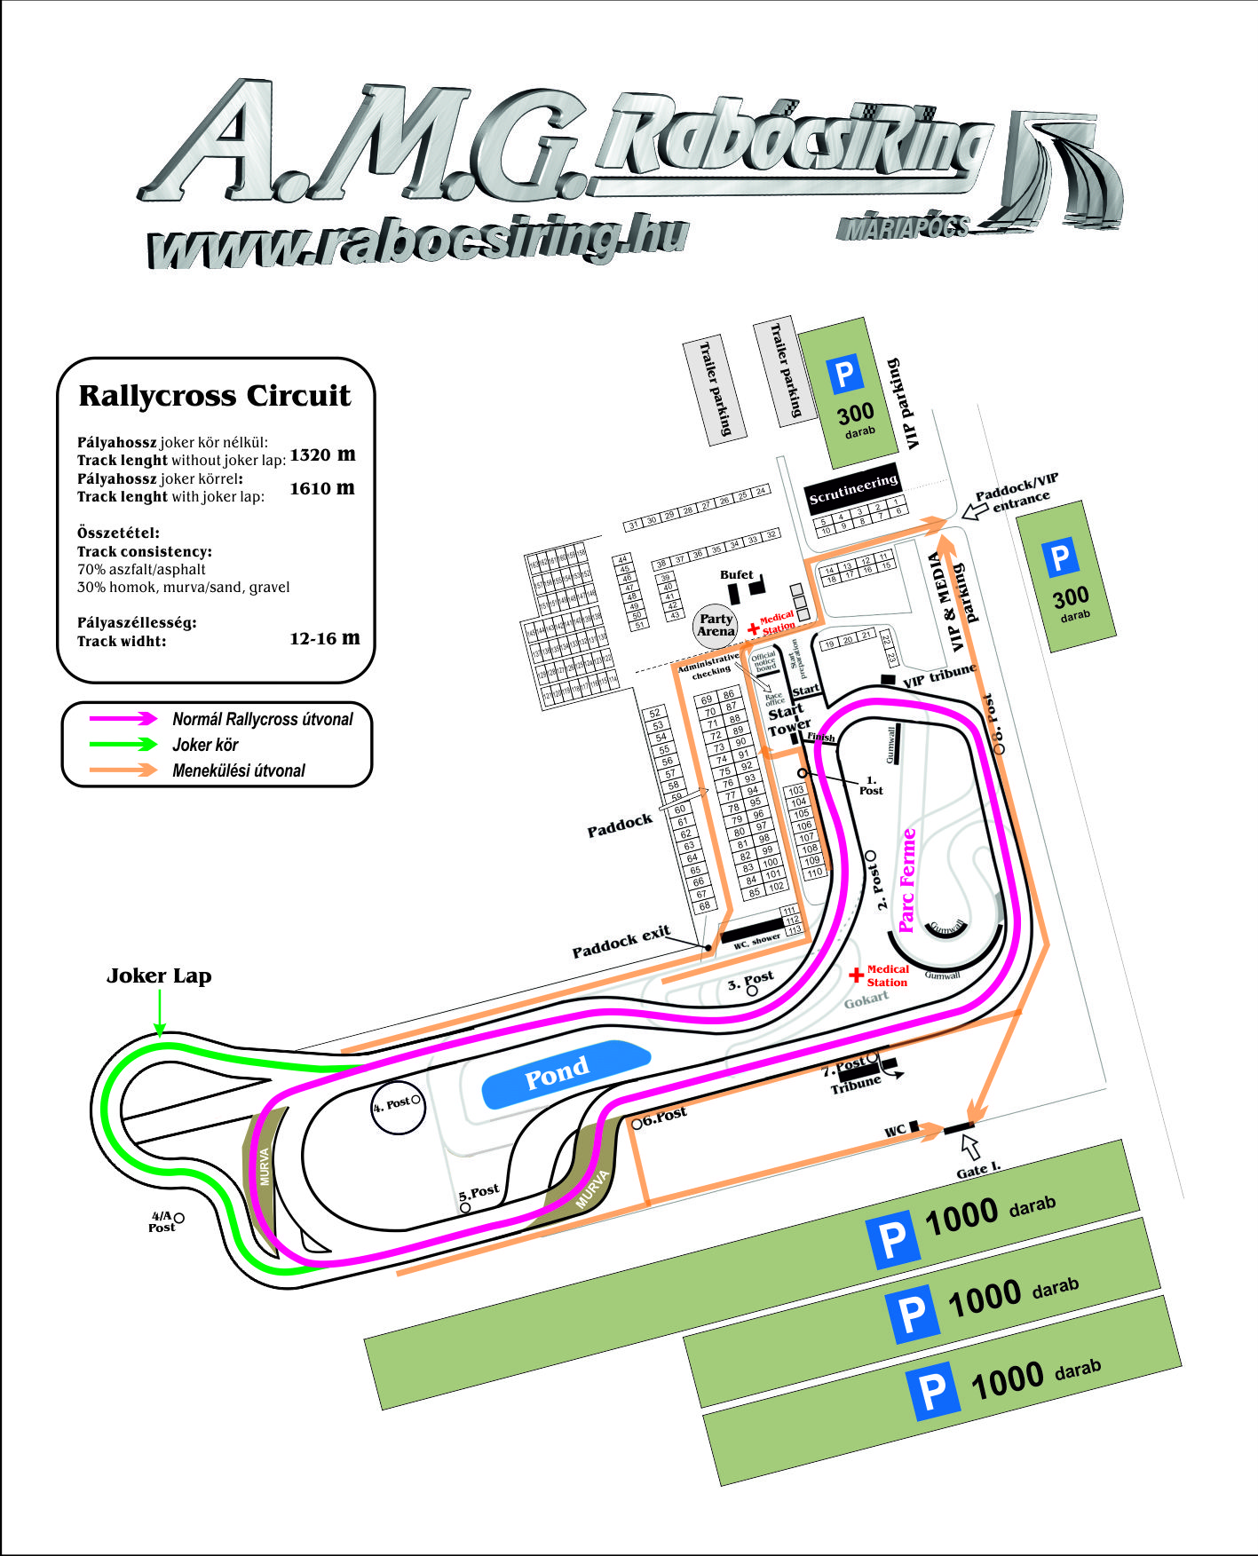

Máriapócs, 26. August 2019.

Authorisation of the supplementary regulation
MNASZ authorisation number: approval in process
Date of Off-Road approval: 04.09.2019.

Chairman of the Off-Road Committee

